**How to Flash the BIOS on 2012/2013 INTEL based Platforms**

**Platform: Orbitz**

**Version: 00.46**

**There are two methods to update the BIOS:**

* **Method 1# is by HPBIOSUPDREC or**
* **Method 2# is by FPTW**
* **Method 3# is by Stratus.**

**Not every BIOSs upgrade will support both methods, please see the matrix below and use the correct upgrade method (V = supported and X = not supported). If both methods are supported then use the HPBIOSUPDREC method since it is faster and easier to follow.**

**If upgrading 2 or 3 revisions ahead of the current system BIOS, then we recommend that you use the FPTW method**

**BIOS UPDATE MATRIX:**

|  |  |  |  |  |  |  |  |
| --- | --- | --- | --- | --- | --- | --- | --- |
| BIOS Flash: From -> To | FPTW | HPBIOSUP-DREC | Stratus | DB | SI | PV | Comments: Whenever there is an “X”, please explain the reason. For example, when HPBIOSUPDREC is an X, add the reason why HPBIOSUPDREC cannot be used. For example, a new ME 1124, or Flash map change, etc. When DB1 is an X, please add in the Comments section the main reason why that release is not compatible with DB1, for example, a GPIO change, a device was moved to another bus, etc. |
| 00.45->00.46 | V | V | X |  | X | V | BIOS has set DeepS3 default disable, cannot support on SI. Only for SI-R & PV system. |
| 93.00->00.46 | V | X | X |  | X | V | BIOS has set DeepS3 default disable, cannot support on SI. Only for SI-R & PV system. |
| 00.44->00.45 | V | V | X |  | V |  |  |
| 00.43->00.44 | V | V | X |  | V |  |  |
| 00.42->00.43 | V | V | X |  | V |  |  |
| 00.41->00.42 | V | X | X |  | V |  | BIOS update GBE in 00.42. Please only use FPTW to update BIOS and don’t try to downgrade BIOS. |
| 00.40->00.41 | V | V | V |  | V |  |  |
| 00.07->00.40 | V | V | V |  | V |  |  |
| 00.06->00.07 | V | V |  | V | V |  |  |
| 00.05->00.06 | V | V |  | V |  |  |  |
| 00.04->00.05 | V | V |  | V |  |  |  |
| 00.03->00.04 | V | V |  | V |  |  |  |
| 00.02->00.03 | V | V |  | V |  |  |  |
| 00.01->00.02 | V | V |  | V |  |  |  |
| 07.02->00.01 | V | X |  | V |  |  | 07.02 is bring up version, 00.01 is first version release, no support HPBIOSUPDREC |

**PLATFORM/RELEASE Specific Notes regarding any known issues that may cause problems with the updating:**

Failure reported – if there is missing information in the comments section of the table above then it needs to be noted here.

**PLATFORM/RELEASE Specific Notes:**

* If the BIOS includes an official signed key, you cannot use the FPTW method to flash the BIOS; you only can use the HPQflash utility to flash the BIOS. All formal releases of the BIOS, i.e. “F.XX”, have an official signed key.
* Refer to the “Comments” section in the **BIOS UPDATE MATRIX** above for each BIOS release to determine the proper path to follow for downgrading your BIOS.

Method 1# **HPBIOSUPDREC Utility**

1. Copy the entire HPBIOSUPDREC directory to your desktop
2. Within the HPBIOSUPDREC directory there may be two subdirectories. These subdirectories have the following name format based on your flash part size:
   * Entry “xxxxE” or
   * Full “ xxxxF

**If neither subfolder exists, proceed to step 3 below.**

Each of the subdirectories contains a copy of the HPBIOSUPDREC utility along with the required supporting files to flash the BIOS based on the flash part size. You will need to copy (again) one of these subdirectories to your desktop. To determine which of these subdirectories to copy to your desktop, you will need to determine your current BIOS configuration.

The easiest was to determine the current BIOS configuration is to simultaneously hold down the FN + ESC key combination to get to the “System Information” screen; then select “Advanced” to see the information below.

Note the “BIOS Version/date” line and specifically the “Hewlett-Packard XXXXF” as below. You will see either XXXXF or XXXXE. The “F” or “E” will identify the BIOS configuration and identify which of the subdirectories to copy to your desktop.

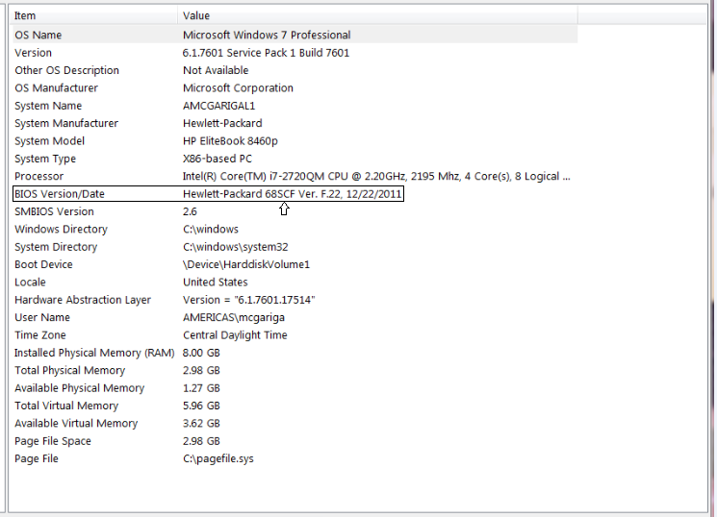

1. Click and run the **HPBIOSUPDREC** application.
2. Follow the on-screen instruction.
3. The System will reboot and the BIOS update process will complete.

Method 2# **FPTW**

Cautionary Note:

Before you use FPTW to flash the BIOS, make sure that the **“Intel Management Engine 8 Components Driver”** is installed on your systems. This should be the case. If you are unsure, either install the driver or go to the Device Manger (DM) to see if the MEI driver is properly installed on your system. You should see the following in the DM:

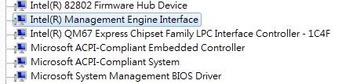

* The User Account Control (UAC) setting needs to be set to DISABLED.
* During the very last step of the BIOS update process, your system may not reboot and will appear to be in the “off” power state. If that happens, wait at least 3 minutes to insure that a reboot does not occur and that the system is indeed in the power off state. Then and only then, you should press the power button to restart.
* This package can support both 64bit and 32 bit OSs. For 64 bit OSs, support is only provided in “TEST mode”, which means, you need to type the command below as the “Administrator” :
  1. Set Test mode on: Bcdedit /set testsigning on
  2. For XP 32 users, please copy all FPTW\files into a new folder with CHOICE_XP.COM and rename CHOICE_XP.COM to CHOICE.COM

To update the BIOS, you need to run the **update.bat file** from the Windows OS by completing the following steps below:

1. Create a directory…Copy the complete BIOS Download folder and put the files in the C:\ Root Directory. .
2. Run the **Command Prompt** as an **Administrator** and change the directory to the location of the BIOS **download folder (For example c:\BIOS)**
3. Execute the "**update.bat"** file and follow the on–screen instructions.

For example: C:\ BIOS\update.bat

Note: This process will require system reboot and execute the "update.bat” after each system reboot repeatedly. The multiple reboots and running of “update.bat” will accomplish the following:

* **Check the ME status.**
* **Backup BIOS/MAC information.**
* **Update the BIOS.**
* **Reboot the system.**
* **Restore BIOS/MAC information.**
* **Reboot the system.**
* **Commit the system.**
* **Reboot the system.**

1. Continue to run the “update.bat” file until the BIOS update is completed. When the update is complete you will see the following message:

"BIOS is successfully updated and this system already be committed. It will force to reboot again to check BIOS/ME status”

**Method 3# Stratus.**

1. Power-on unit from Off state.
2. Press F10 or ESC key to enter F10 BIOS Setup.
3. Select “Update System BIOS”
4. Select “Update BIOS from HP.Com”
5. Select “Check HP.Com for BIOS Updates”
   1. System will check for updates
6. Select “Update to <version number>” button to start the BIOS update
7. System will reboot twice to complete the BIOS update and boot into OS

**Notice:**

1. Please don’t downgrade BIOS to 00.12 on SI1 unit.
2. The EEUPDATE tool is required the LAN driver installed and it should not any yellow mark on LAN device.
3. **Due to the fptw /greset command could get fail. The system will do a shutdown process and please do a G3 power state manually(remove AC/DC) after system shutdown already.**
4. The BiosConfigUtility tool is required the MPM unlock mode only. Please use SMC key to reset the MPM mode if the MPM mode has locked.

(SMC process: Put SMC binary “SMC.bin” to USB key with fat32 format and attach to test units. Hold the SMC hotkey Win+Up+Down then power on.)

1. Please use MAC.bat to update the MAC/SSID for LAN device in “MAC update” folder. Sample command: mac 8888888878